**User Manual of Judge Details**

**There are two forms in Judge Details:**

1. **Judge Form:**

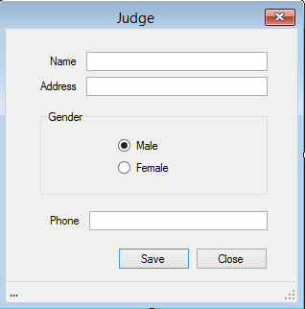

* **This is Judge Form where the judge information related to the respected case is stored.**

1. **Judges List Form:**

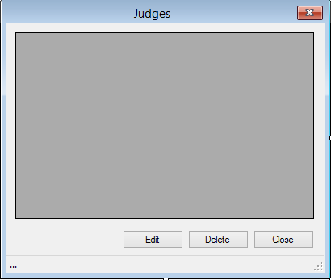

* **This is Judges List Form through which advocate can view, edit and delete lists of judges.**